Philosophy, Religion and Ethics
Email completed booklet to Mrs Amy Thompson (RS Subject Leader) by 15th June:
alt@tda.education
Ethics
- Natural Moral Law
- Situation Ethics
- Utilitarianism
- Kantian Ethics
- Business Ethics
- Euthanasia
- Meta-Ethics
- Conscience
- Sexual Ethics
Philosophy
- Ancient Greek Philosophical Influences
- Soul, Mind and Body
- Arguments for the Existence of God from Observation
- Arguments for the Existence of God from Reason
- Religious Experience
- Problem of Evil
- Nature and Attributes of God
- Religious Language: Apophatic and Cataphatic
- Religious Language: 20th Century

Religion (Buddhism)
- Foundations
- Insights
- Living
- Development
- Society
- Challenges

Textbooks used in year 12 and 13
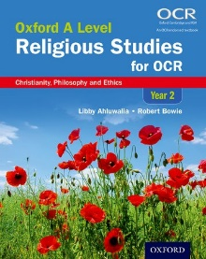  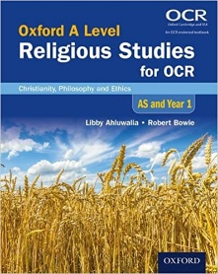 | Oxford A Level Religious Studies for OCR: AS and Year 1 Student Book: Christianity, Philosophy and Ethics (2016)  Oxford A Level Religious Studies for OCR: Year 2 Student Book: Christianity, Philosophy and Ethics (2017) | Libby Ahluwalia and Robert Bowie
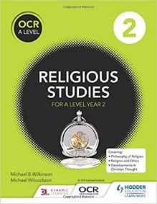  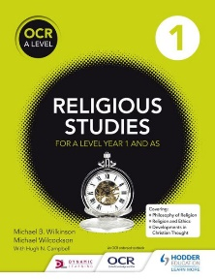 | OCR Religious Studies A Level Year 1 and AS, Hodder Education (2016)  OCR Religious Studies A Level Year 2, Hodder Education (2017) | Michael. B. Wilkinson, Michael Wilcockson and Hugh Campbell
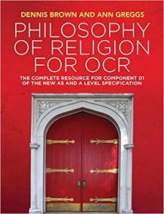  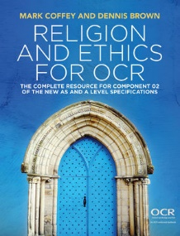 | Religion and Ethics for OCR, Polity Press (2018)  Philosophy of Religion for OCR, Polity Press (2018) | Mark Coffey and Dennis Brown
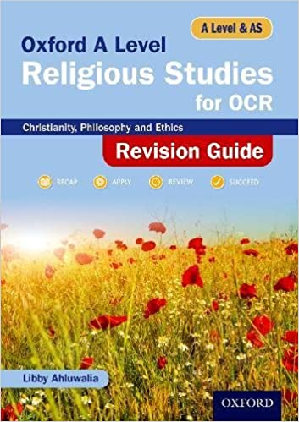 | Oxford A Level Religious Studies for OCR Revision Guide (2018) | Libby Ahluwalia
Task 1: Crash Course Philosophy – What is Philosophy? https://www.youtube.com/watch?v=1A_CAkYt3GY&list=PL8dPuuaLjXtNgK6MZucdYldNkMybYIHKR&t=551s
Watch the video and answer the following questions:
“If I’m not truly free to make my own decisions, or choose my own actions, then how can I be held accountable for them?” – what is meant by this? How are we not free to make our own decisions?

What is the significance of ancient Greece to philosophy? What were the Ancient Greeks trying to do?

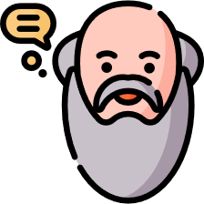
What is the goal/purpose of philosophy?
Why is logic so important to philosophers?
What is value-theory?
What is epistemology?
What is metaphysics?
What are some examples of the big questions that philosophy has tried to address?
Task 2: The Balloon Debate
A hot air balloon is filled with six people but is too heavy. If they continue on course, the hot air balloon will crash into mountains resulting in the death of all six. You need to choose two people to kick out of the hot air balloon to keep it light enough to make it over the mountain and land safely. Read through each biography carefully and decide which 2 will go. In the boxes at the bottom of the page, write down a defence for each person for why they should stay and an argument for why they should be one of the two who are kicked out.
Person | Why they should stay in the balloon | Why they should be kicked out of balloon
Young boy
Elderly lady
Doctor
Young businessman
Mother
Baby
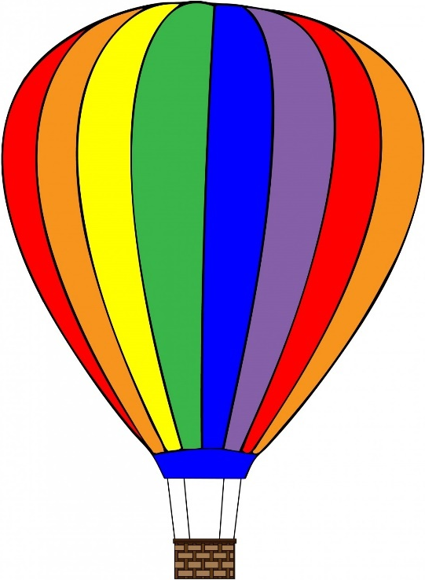
Young boy – 7 years old. Likes to watch films and play football
Elderly lady – 90 years old. Enjoys knitting and watching TV. Big fan of the Queen. Volunteered every weekend to help feed the homeless
Female doctor – 45 years old. Works long hours as a Doctor in a large city hospital. Enjoys walks with her girlfriend and dog in her free time
Mother and baby – 30 and 1 years old. This is the mother’s first baby. Doesn’t know who the father is but is able to provide for baby alone.
Young businessman – 25 years old. Just beginning his career after doing an apprenticeship for a local business. Has been promoted several times – very good at his job.
I would kick out these two people because…
Task 3: The Life of the Buddha
Research the significant things that happened in the life of the Buddha, from before his conception to his death. Annotate the icons with what you think they are referring to.
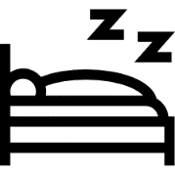
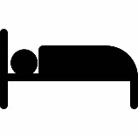
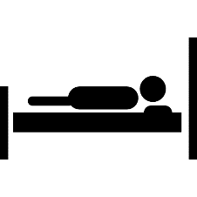
Which part of the Buddha’s life did you find the most interesting/surprising?

Task 4: Agree or Disagree?
 | Agree or disagree? | Why? Give a reason
Medicines should be tested on animals before they are tested on people
Cosmetics should be tested on animals before being used on humans
It is wrong to help someone die who wants to die
Countries with more money should not give money to poorer countries
Businesses have a duty to their customers to make products as cheap as possible – regardless of how unethical that might be
Stealing is always wrong
You should have a choice on whether you want to contribute to society through taxes
The death penalty should be brought back to the UK for the most serious crimes
We live on the planet which means we should have unlimited access to its resources – renewable or not it is our right
Feedback:

