Year 12
Based on an activity by Deborah E Allen
Thomas Deacon Academy
Year 12
Zoe takes a dive

Zoe takes a dive

Stage 1
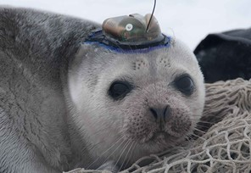
It’s austral summer outside, but Steve’s not feeling quite as lucky as he did several months ago about having the opportunity to spend his extended holiday break assisting a research team on a National Science Foundation sponsored expedition to Ross Island, Antarctica. The groups he’s working with, headed by his university faculty advisor has some new telemetry devices he’s been trying out by attaching to Weddell seals (Leptonychotes weddelli). These devices have enabled him and the team to monitor heart rate, body temperature, blood pressure, cardiac output (blood flow in the ascending aorta), and organ blood flows during the seals’ descents and ascents from voluntary dives. They also send signals from a depth recorder attached to the animals.
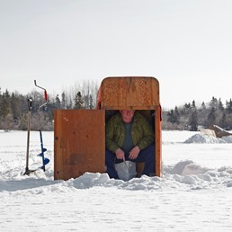
Right now, Steve is cold, hungry and miserable, having spent several hours in a small hut over a manmade hole in the sea ice about 15 kilometres offshore. He and Samantha (another student on their expedition) are waiting for their latest subject (who they’ve christened “Zoe“) to ascend from a dive. She has been down for about 50 minutes already, and when she ascends Steve and Samantha will still have about 3 hours of analytical work to do on the post-dive blood samples they’ll have to collect from her. Just as Steven and Sam are about to head back to the base camp, thinking “Zoe’ must be dead, he notices her vibrissae beginning to emerge from the water.

Questions to ponder:

What physiological and physical problems must the seal have faced in the course of this lengthy dive?
Why didn’t the seal get the “bends’, despite the relatively rapid ascent that Steve’s telemetry equipment recorded?
Wouldn’t a human diver have a problem with an ascent this fast?

Stage 2

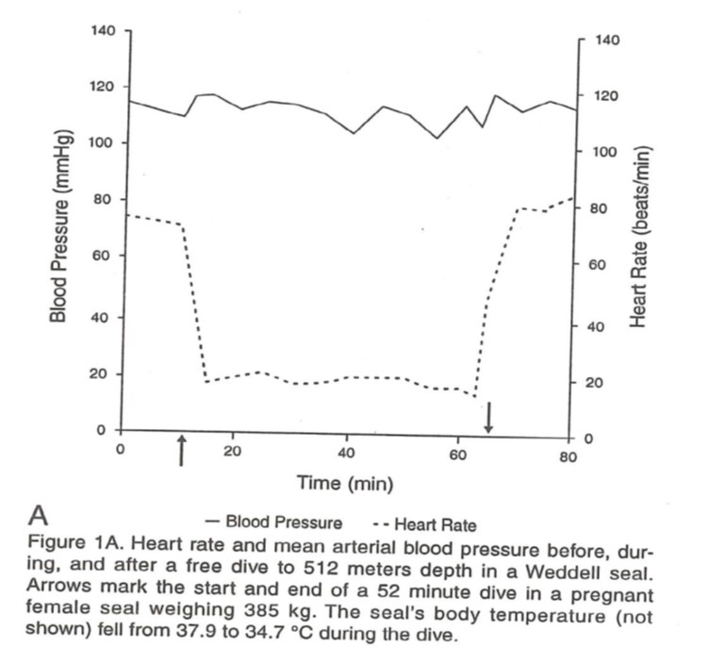
The next day, his misery forgotten, Steve has some results he is eager to show his advisor. He stayed up late using the facility’s computer to graph some of the data he and Samantha have been collecting, and for some of the biochemical data, he has noticed some interesting differences between yesterday’s dive and a previous one (also by “Zoe”) of shorter duration.

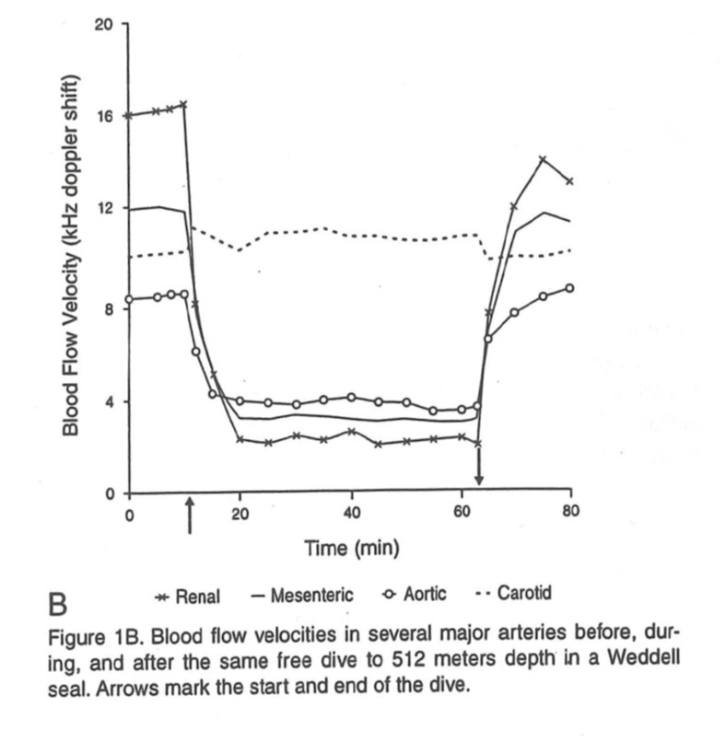

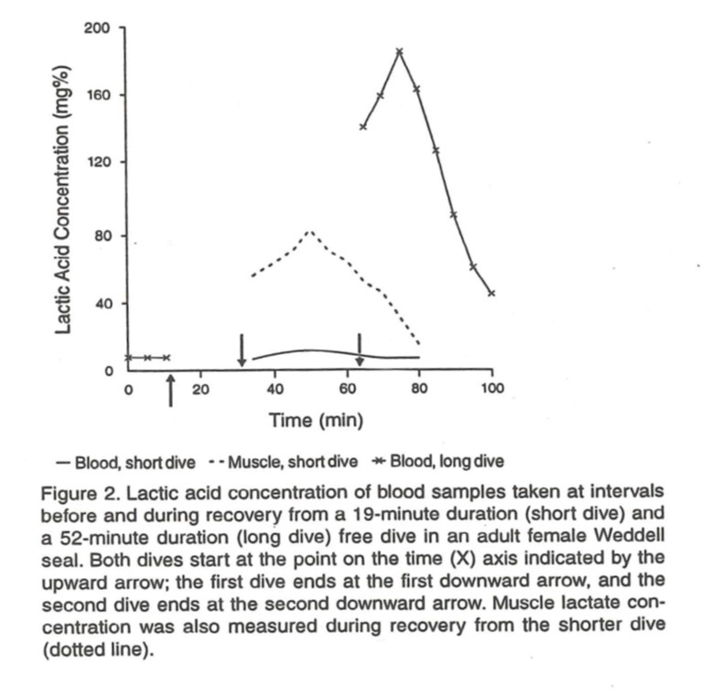

Questions:

Why might these cardiovascular changes (in Figure 1) be useful to a diving seal? Would a diving human experience these same changes?
Steve and the team weren’t set up to measure lactic acid during the dive, but he has some good ideas (based on pre- and post dive values) about how it must have changed. Complete the graph (Figure 2) by drawing in the curve for what you think happened to blood and muscle lactic acid concentration during both the longer and shorter dives.
Although ventilator rate was not measured, how would you anticipate that it would change (from the seal’s normal breathing pattern before the dive) during the recovery from the long dive? What mechanisms would account for the change?

Stage 3

Steve is back in his room, contemplating the rough draft of a paper his advisor has suggested he write as part of an independent study project. Sam is going to write up the cardiovascular data. Steve is trying to compare some of the biochemical information the Antarctic research team collected for Weddell seals with information he has been able to piece together from the scientific literature on other mammals, including some pinnipeds and some cetaceans. He has got as far as drawing a graph of the data for the most likely predive conditions, but not for how the data determined during diving conditions might look. He is hoping that the comparative data will support his ideas about how diving mammals have adapted to the periodic need to survive oxygen deprivation. An interesting question pops into mind, however, as he thinks of that cold and miserable day that he and Samantha waited for Zoe the seal to ascend from her 52 minute dive.
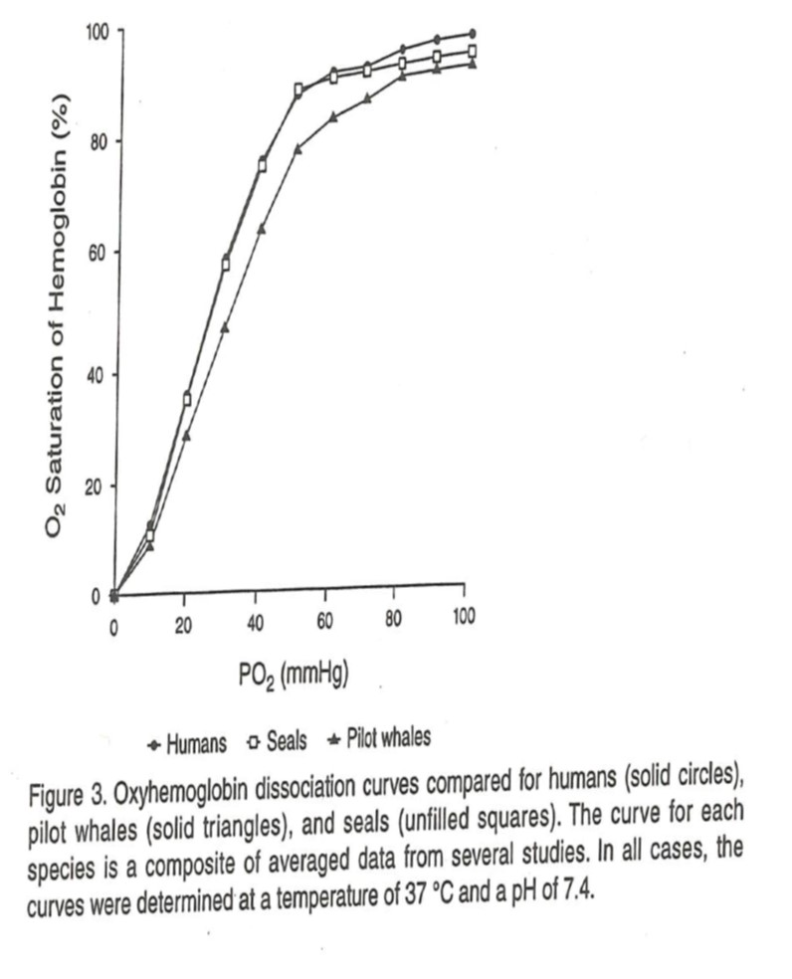

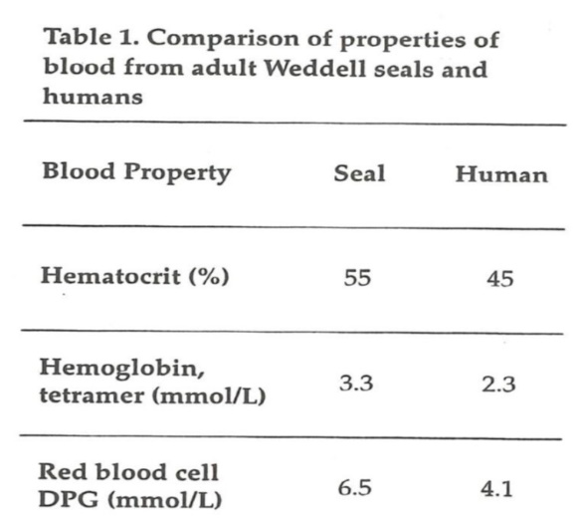

Questions to ponder:

Why do you think that Steve thought it was important to report (in Figure 3) the conditions under which the oxyhaemoglobin dissociation curves were plotted were determined? Why should this matter?
Help Steve finish the graphs – that is, what might the curve for the seal look like during conditions more nearly similar to those during a dive?
Using the information provided in Table 1, how would the amount of haemoglobin found in each red blood cell (the mean corpuscular haemoglobin concentration) compare in the two species?
What important difference between seal and human blood properties is missing from Steve’s Table 1?
Steve’s thought was about Zoe’s near term foetus – do you think it survived her deep and prolonged dive? Why or why not?

