Health and Social Care (HSC)
Transition Project 2
Working in HSC means that you could work with all sorts of different people, of all different ages, backgrounds and beliefs. This project will help you to think about some of the different challenges that different individuals might face and that you as a HSC worker might need to manage.
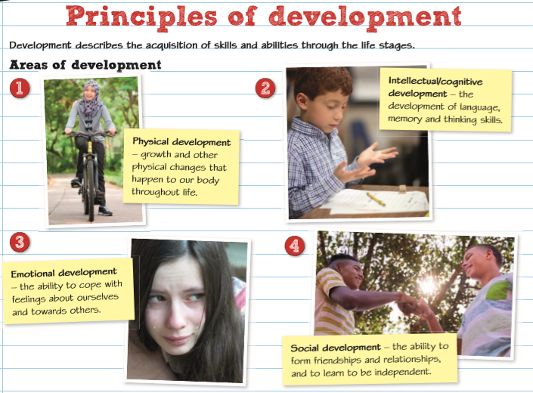
Development through the life stages
If you have already completed your Level 2 in HSC you will have learned about how people develop through the life stages. In this part of the project we are going to consider the impact of different events on individuals.
There are four key areas of development: Physical, Intellectual, Emotional and Social. We often refer to these as PIES.

Task 1a: Describe each area of development in your own words:
- Physical development is:
- Intellectual development is:
- Emotional development is:
- Social development is:
Task 1b: Now give examples for each of the areas of development for each life stage for example in infancy babies learn to roll over – this is physical development.
Life stage | Physical | Intellectual | Emotional | Social
Infancy
0-2 years

Early Childhood
3-8 years

Adolescence
9-18 years

Early Adulthood
19-45 years

Middle Adulthood 46-65 years

Later adulthood
65+

Predictable and Unpredictable Events
During our lifetime we face some predictable events such as starting school, or going through puberty, and other unpredictable events such as serious illness or accidents. Each of these events will have an impact on our development – sometimes this will be positive, sometimes negative and sometimes both!
In addition, although they might particularly affect one area of development, for example puberty causes lots of physical changes, they will usually also have an impact on more than one area of development, for example going through puberty will have a big impact on how the individual feels about themselves (their self-esteem), this is emotional development, it might also impact on their relationships with their friends and family which is social development.
Task 2: For each of the mini case studies below you should identify which life stage the individual is in, you should describe any key changes, and then assess how the event will impact on their development. You should try to consider the impact on each area of PIES if you can and include both positive and negative impacts.
Identify | - Show the main features, purpose or points of something
Describe | - Give a clear objective account of the main points of information  - Show your knowledge of a topic  - May give a relevant example
Assess | - Give careful consideration of a variety of factors or events that apply to a situation  - Identify those factors that are most important or relevant  - Provide a conclusion

- Ami is 4 years old, it is her first day at school.
- Marley is 12 years old, he is beginning to go through puberty. You should also include a description of the physical changes that Marley will experience.
- Mairah is 18, she is going to university and it is the first time that she has lived away from home.
- Salma is 29 and has just had her first baby.
- Seb is 33, he is obese and has just been diagnosed with type 2 diabetes.
- Kane is 44, he has 3 young children, he has just separated from his wife and they are trying to work out how best to continue to share the care of their children.
- Amelie is 52 and is going through the menopause.
- Georgio is 82, his wife of 60 years died last year and he is now living with his son and daughter in law. He has a large family who come to visit him regularly.
Equality and Diversity
It is not just our age which affects our development and life experiences. When working in HSC you will meet individuals from a variety of backgrounds, and it is essential that they are all treated with dignity and respect.
One way in which we can ensure that we do this is through person centred care. This is about focusing on the specific needs of each individual, ensuring that their preferences, needs and values guide our decisions and the care we provide. For example, if a service-user (this is what we call those who use HSC services such as patients) is vegetarian we must ensure that any food provided meets this preference, if they have a religion that they are provided with a place to pray or that their religious leader is able to visit them. Person-centred care is about ensuring that you get to know each service user as an individual, that they are able to make informed decisions about their care and that we respect their choices and values.
For more about person-centred care you could watch this video: https://www.youtube.com/watch?v=pj-AvTOdk2Q
Task 3: Watch this video https://www.youtube.com/watch?v=zRPM_pqaPp4.
Now explain how HSC professionals can ensure that each service user feels respected and valued. Why is this important?
Explain | - Give details and clear reasons to support the points you make  - Include evidence to support your point of view

The Equality Act 2010 is a piece of legislation (a law) that protects the rights of individuals and promotes equality of opportunity for all. It ensures that individuals or groups of individuals are treated fairly and equally to meet their specific needs.
The Equality Act 2010 brings together over 116 separate pieces of legislation into one single Act! The nine main pieces of legislation that have merged are:
- the Equal Pay Act 1970
- the Sex Discrimination Act 1975
- the Race Relations Act 1976
- the Disability Discrimination Act 1995
- the Employment Equality (Religion or Belief) Regulations 2003
- the Employment Equality (Sexual Orientation) Regulations 2003
- the Employment Equality (Age) Regulations 2006
- the Equality Act 2006, Part 2
- the Equality Act (Sexual Orientation) Regulations 2007
Person-centred care and legislation such as the Equality Act 2010 promote that individuals should be given choice, be valued and have a right to determine the course of their own lives.
Sometimes in HSC we face difficult decisions about what is best for our service users and, whilst it is important to consider their own wishes, we may find that there are some ethical dilemmas in doing this.
Ethical dilemma | A situation when a difficult decision must be made about which course of action is best, but no matter what course of action is taken, some ethical principle is compromised. In other words, there is no perfect solution.
Some examples of ethical dilemmas:
- a patient with an eating disorder is dangerously underweight, the doctor wants to bring them into hospital for monitoring and to ensure they are sticking to their diet plan – the patient doesn’t want to go into hospital.
- an older person who is developing dementia wants to remain in their own home but social workers are concerned that they are not safe to do so.
- a young person with Down’s syndrome is having a relationship with another young person with a learning disability and they want to live together.
- a midwife finds out that one of her pregnant ladies is smoking cannabis
In each of these cases the service user has a right to choose how they live their life but there are difficulties with these choices.
Task 4: Select an ethical dilemma – this could be a real case (see below), one of the examples above, or you could create your own case study (but don’t make it too complicated!).
- Outline the ethical dilemma clearly.
- Discuss the potential choices that could be made
- Assess each of the potential choices showing their relative strengths and weaknesses. You could use evidence from the resources below to help you with your argument.
- Conclude on what you think the decision should be and how will this impact on the individual’s right to make their own choices about their life and their care.
Some interesting case studies:
Note: these cases may be upsetting, please choose a case that you feel able to look into in more detail.
When parents disagree with medical professionals:
- Charlie Gard: https://www.ncbi.nlm.nih.gov/books/NBK537990/ and https://www.bbc.co.uk/news/uk-england-40423371
- Ashya King: https://www.theguardian.com/uk-news/2015/sep/24/parents-ashya-king-put-him-risk-report-says
- Tafida Raqeeb: https://www.bbc.co.uk/news/uk-43893709
Right to die: ‘Martin’ and Tony Nicholson:
- https://www.bbc.co.uk/news/uk-england-19341722
- https://www.bbc.co.uk/news/uk-33599788
Woman with severe learning difficulties to have an abortion: https://www.theguardian.com/world/2019/oct/11/woman-severe-learning-disabilities-abortion-judge-rules
An interesting article with some example dilemmas: http://news.bbc.co.uk/1/hi/health/7514740.stm
Case study: 89 year old woman with Alzheimer’s wants to remain independent: https://www.scie.org.uk/mca-directory/mca-tailored-for-you/health/pan-london-commissioner-toolkit/case-study-6.asp
Other helpful resources and websites:
- Ethical issues overview: http://www.ukcen.net/ethical_issues
- Guidance on consent: https://www.gmc-uk.org/ethical-guidance/ethical-guidance-for-doctors/consent
- Royal College of Nursing: Ethics: https://rcni.com/hosted-content/rcn/fundamentals-of-end-of-life-care/ethics
- Drugs in pregnancy: https://www.msdmanuals.com/home/women-s-health-issues/drug-use-during-pregnancy/drug-use-during-pregnancy
- What’s wrong with making it a crime to be pregnant and have a drug problem?: http://www.advocatesforpregnantwomen.org/facts/what.htm
- When women have learning disabilities: https://www.nursingtimes.net/archive/when-parents-have-learning-difficulties-26-04-2001/
Codes of practice (guidance for professionals on how they should behave professionally):
- Nursing and midwifery: https://www.nmc.org.uk/standards/code/
- Doctors: https://www.gmc-uk.org/about/how-we-work/governance/council/code-of-conduct
- Social Workers: https://www.scie.org.uk/workforce/files/CodesofPracticeforSocialCareWorkers.pdf?res=true

Please return your completed work to Mrs. Jackson: mtj@tda.education by Friday 10th July

