Transition tasks in preparation for study.
This is now your opportunity to work on and embed the key skills that will help you to access the course and achieve that deeper understanding. These key skills will be assumed knowledge when we are teaching the A level course, and will allow you to access new topics more easily. You should already have completed the first 3 tasks and submitted your solutions.
Transition Work Topics
- Simultaneous Equations
- Expanding Brackets
- Factorising
- Quadratics
- Completing the square
- Algebraic Fractions

Transition work tasks
- For each topic you should first take notes from the videos. You may choose Corbett Maths or the Hegarty Maths. You do not need to do both.
- Go through the worked examples, and complete the ‘your turn’ section using the same method.
- Complete the questions provided, and then self-mark from the answers provided.
- Complete the assessment questions for each topic, and e-mail a photo or scan of the work to nwa@tda.education by 10/07/20.

Optional tasks
To help prepare students for studying A level Maths Mr Hegarty has been running a series of live YouTube lessons. He has also made these videos available on his YouTube channel.
https://www.youtube.com/playlist?list=PLxHVbxhSvleR5tntP2FxYBJCoY5-pD_Z8

Task 4 – Solving Quadratics (by factorising)

1 – Note taking
You will need to take notes from one of the following sources. Corbett Maths videos are freely available. If you have a Hegarty Maths login from Y11, then you may prefer to use that.
Corbett Maths video: 266 – Solving quadratics - https://corbettmaths.com/2013/05/03/solving-quadratics-by-factorising/
Hegarty Maths video: 230 – 233 Solving Quadratic equations (by factorising)

2 – Worked Examples
Read through the Worked Examples, then use the same method and layout to attempt the ‘Your turn’.

Worked Examples :
My turn: Solve
$$a) x^{2}+3x=0$$
Factorise by taking out the common factor
$$x\left(x+3\right)=0$$
Treat as separate linear equations and solve
$x=0 or x+3=0$
Therefore $x=0 or x=-3$
$${b) x}^{2}-7x-18=0$$
List the pairs of numbers that multiply to give the constant, (in this case -18), and add to give the coefficient of $x$, (in this case -7).

Your turn: Solve
$$a) x^{2}+11x=0$$

$${b) x}^{2}+3x-40=0$$

$1 ×-18$ $6×-3$
$2 ×-9$ $9×-2$
$3 ×-6$ $18×-1$
Write the factors in double brackets
$(x+2)(x-9)$ = 0
Treat as separate linear equations and solve
$x+2=0 or$ $x-9=0$
Therefore $x=-2 or x=9$

Worked Examples (continued) :

My turn: Solve
$$c) 4 x^{2}-9=0$$
Factorise using the difference of two squares, write the factors in double brackets
$$\left(2x-3\right)\left(2x+3\right)=0$$
Treat as separate linear equations and solve
$2x-3=0 or$ $2x+3=0$
Therefore
$$x=\frac{3}{2} or x=-\frac{3}{2}$$

$${d) 20x}^{2}+3x-2=0$$
Using the method from task 3 (factorising), factorise the quadratic into double brackets.
$$\left(5x+2\right)\left(4x-1\right)=0$$
Treat as separate linear equations and solve
$5x+2=0 or$ $4x-1=0$
Therefore
$$x=-\frac{2}{5} or x=\frac{1}{4}$$

Your turn: Solve
$$c) 16x^{2}-25=0$$

$${d) 4x}^{2}+21x+5=0$$

3 – Practice

Complete the four tasks, and use the answers to mark your work after.
Task 1: Solve

Task 2: Solve

Task 3: Solve
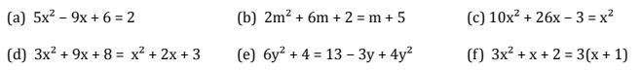

Task 4: Solve

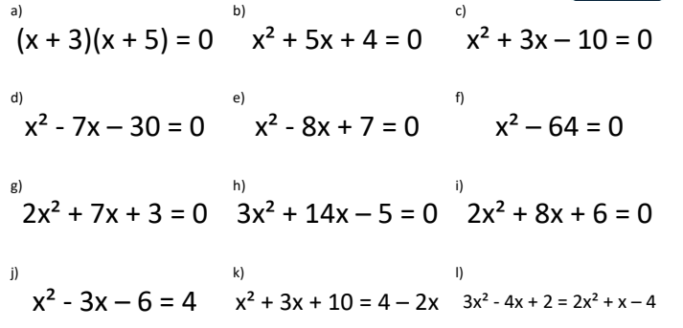

Answers 1:
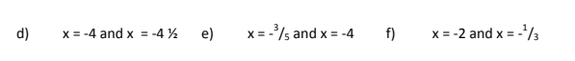

Answers 2:

Answers 3:
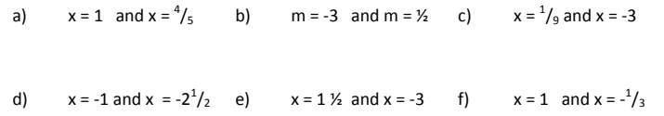

Answers 4:
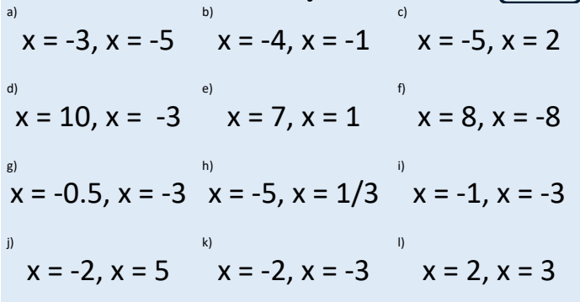

4 – Assessment

- Solve $x^{2}-7x+12=0$

- Solve ${2x}^{2}=x+3$

- Solve $y^{2}+8y-32=8y-16$

Task 5 – Completing the Square

1 – Note taking
You will need to take notes from one of the following sources. Corbett Maths videos are freely available. If you have a Hegarty Maths login from Y11, then you may prefer to use that.
Corbett Maths video:
10 – Completing the Square - https://corbettmaths.com/2013/12/29/completing-the-square-video-10/
267a – Solving by completing the square - https://corbettmaths.com/2013/12/29/completing-the-square-video-10/
Hegarty Maths video: 235 – 237 Completing the square, and 238-239 Solving by completing the square

2 – Worked Examples
Read through the Worked Examples, then use the same method and layout to attempt the ‘Your turn’.

Worked Examples :
My turn: Write in the form ${(x+a)}^{2}+b$

$$a) x^{2}+6x+5$$

Write out the perfect square with matching quadratic and linear terms:
$${\left(x+3\right)}^{2}=x^{2}+6x+9$$
Complete the square by making the adjustment for the constant term to match:
$${(x+3)}^{2}-4=x^{2}+6x+5$$

$${b) x}^{2}-14x+50$$
Write out the perfect square with matching quadratic and linear terms:
$${\left(x-7\right)}^{2}=x^{2}-14x+49$$
Complete the square by making the adjustment for the constant term to match:
$${\left(x-7\right)}^{2}+1=x^{2}-14x+50$$

Your turn: Write in the form ${(x+a)}^{2}+b$

$$a) x^{2}+8x+7$$

$${b) x}^{2}-16x+65$$

$$c){2x}^{2}+8x-3$$
Take out a factor of 2 from the first two terms so that the $x^{2}$ term is on its own.
$${2[x}^{2}+4x]-3$$

Complete the square with the expression inside the bracket:
$${2[(x+2)}^{2}-4]-3$$

Expand out the square brackets:
$${2(x+2)}^{2}-8-3$$

Simplify:
$${2(x+2)}^{2}-11$$

$$c){4x}^{2}+8x-1$$

3 – Practice

Complete the tasks, and use the answers to mark your work after.
Task 1: Write in the form ${(x+a)}^{2}+b$
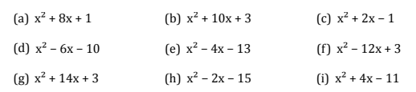

Task 2: Write in the form ${a(x+b)}^{2}+c$
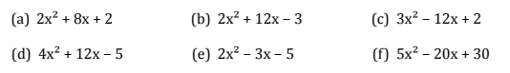

Task 3: Write in completed square form:
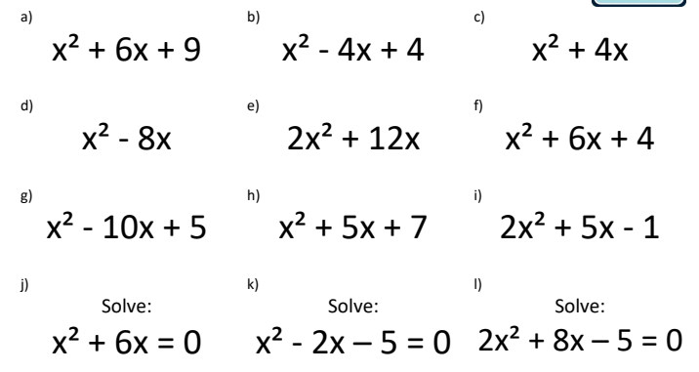

Answers 1:
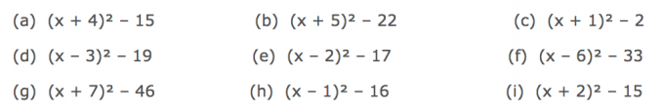

Answers 2:

Answers 3:
- ${(x+3)}^{2}$
- ${(x-2)}^{2}$
- ${(x+2)}^{2}-4$
- ${(x-4)}^{2}-16$
- ${2(x+3)}^{2}-18$
- ${(x+3)}^{2}-5$
- ${(x-5)}^{2}-20$
- ${(x+2.5)}^{2}+0.75$
- ${2(x+1.25)}^{2}-4.125$
- $x=0 or x=-6$
- $x=1+\sqrt{6} or x=1-\sqrt{6}$
- $x=-2+\sqrt{6}.5 or x=-2-\sqrt{6}.5$

4 – Assessment

- Write in the form ${(x+a)}^{2}+b$
$$x^{2}+6x+1$$

- Write in the form ${a(x+b)}^{2}+c$
$$2x^{2}-6x+3$$

- Solve by completing the square
$$x^{2}-8x=-4$$

Task 6 – Algebraic Fractions

1 – Note taking
You will need to take notes from one of the following sources. Corbett Maths videos are freely available. If you have a Hegarty Maths login from Y11, then you may prefer to use that.
Corbett Maths video: 24 – Simplifying Algebraic Fractions – https://corbettmaths.com/2013/01/19/simplifying-algebraic-fractions/
Hegarty Maths video: 229 Simplifying Algebraic Fractions (involving quadratics)

2 – Worked Examples

Read through the Worked Examples, then use the same method and layout to attempt the ‘Your turn’.

Worked Examples :
My turn:
$$a) \frac{36ab}{48bcd}$$
Look to cancel the numbers by finding common factors e.g. divide the numerator and denominator by the common factor of 12
$$\frac{3ab}{4bcd}$$
Re-write the variables in expanded form, cancelling out where necessary
$$\frac{3a}{4cd}$$
$$b) \frac{{12x}^{2}+24}{6}$$
Factorise the numerator by taking out a common factor of 12
$$\frac{{12(x}^{2}+2)}{6}$$
The denominator and numerator can now be cancelled down further by dividing both by 6.
$$2\left(x^{2}+2\right)$$

Your turn:
$$a) \frac{45xy}{55xz}$$

b) $\frac{36x+48}{12}$

Worked Examples (continued):

My turn:
$$c) \frac{{2x}^{2}+4x}{x^{2}+5x+6}$$
Factorise the numerator and denominator
$$\frac{2x(x+2)}{(x+2)(x+3)}$$
Cancel the common factors
$$\frac{2x(x+2)}{\left(x+2\right) (x+3)}$$
$$\frac{2x}{(x+3)}$$

$$d) \frac{{2x}^{2}-x-3}{{4x}^{2}-9}$$

Factorise the numerator and denominator
$$\frac{(2x-3)(x+1)}{(2x-3)(2x+3)}$$
Cancel the common factors
$$\frac{(2x-3)(x+1)}{(2x-3)(2x+3)}$$

$$\frac{x+1}{(2x+3)}$$

Your turn:
$$c) \frac{{2x}^{2}+8x}{x^{2}+2x-8}$$

$$d) \frac{x^{2}+3x-70}{x^{2}-100}$$

3 – Practice

Complete the four tasks, and use the answers to mark your work after.
Task 1: Simplify
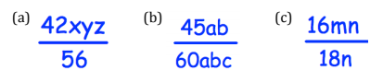
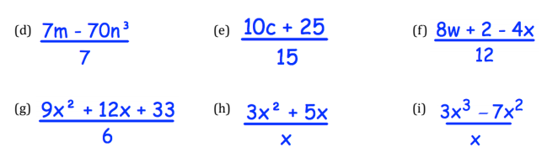

Task 2: Simplify
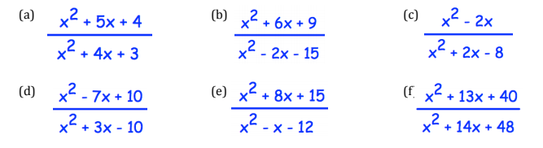

Task 3: Simplify
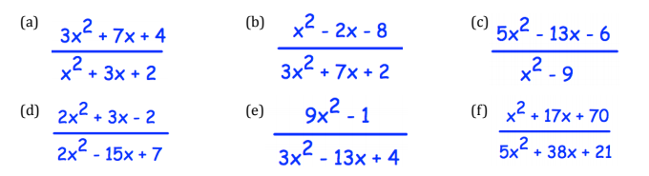

Task 4: Simplify

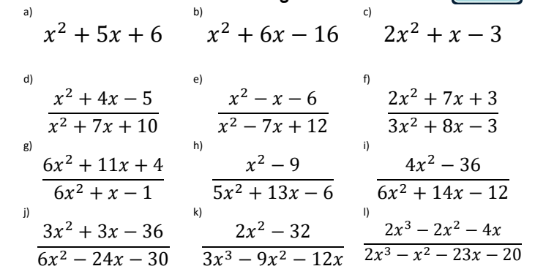

Answers 1:
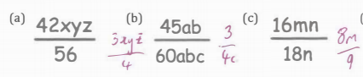
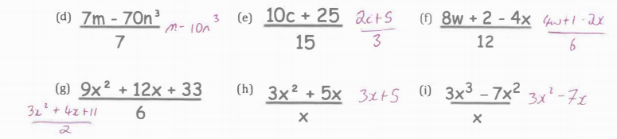

Answers 2:
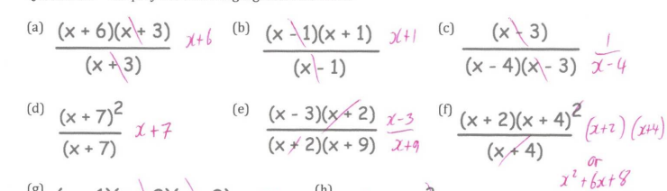

Answers 3:
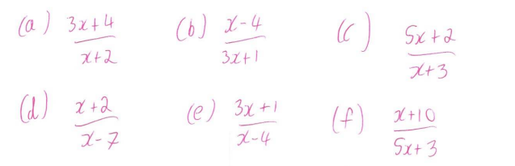

Answers 4:
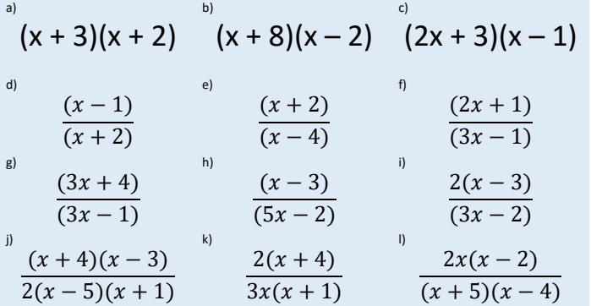

4 – Assessment

- Simplify $\frac{{6x}^{2}+3x}{3x}$

- Simplify $\frac{x^{2}+7x+12}{2x+8}$

- Simplify $\frac{4x^{2}-81}{{2x}^{2}-7x-9}$

