Day 1 – Pages 1 to 5
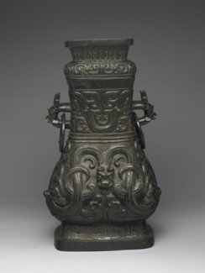

Questions to think about

- What do the letter BCE mean?
- What other great nations were present during 1600BCE to 1046 BCE?

Questions to answer

- What was the Shang? (1 mark)
- Why is there not much known about who ruled before the Shang? (2 marks)
- On page 3, it states, they would frequently fight battles with neighbouring settlements.’
What does the word neighbouring mean in this sentence? (1 mark)
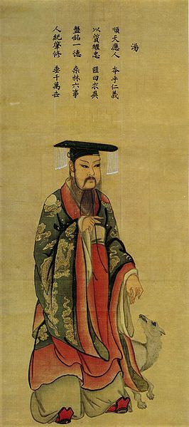
- Why do you think that there were battles between different settlements? (2 marks)
- Name 3 of the different capitals that the Shang people lived in. (2 marks)
- How many different kingdoms was Tang able to gain support from? (1 mark)
- Do you think it was right that Tang was able to create a new dynasty? Give reasons for your answer (2 marks)
- On page 5, it says that boys only were allowed to succeed the throne. Do you think this is fair? Give reasons for your answer. How is that different to now? Give an example.

