Day 3 – Pages 8 to 11

Questions to think about

- How were the peasants different to the noblemen?
- What made the artisans desired by the noblemen?

Questions to answer
- The peasants had to fight for their king during battles. What other job did they have? (1 mark)
- An artisan’s life was much more comfortable than a peasant’s. Give 2 reasons for this. (2 marks)
- The use of currency was different during the Shang Dynasty. Explain why the cowry shells were effective to use as currency. (2 marks)
- The city walls were 10m tall and 20m in width. Why do you think it was important to have walls like this?
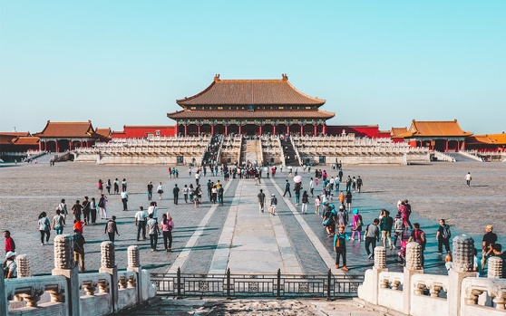
- Explain the process about how Shang buildings were formed. (2 marks)
- How were the buildings different between the Han and Shang Dynasty? (1 mark)
- What evidence is there that the architecture remained relevant and unchanged for many centuries? (1 mark)

