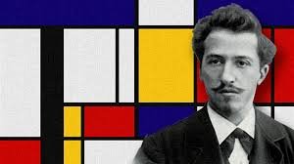

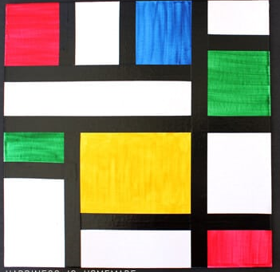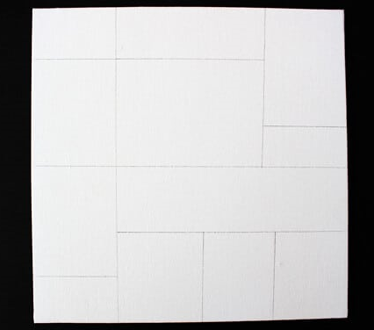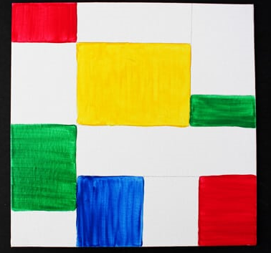**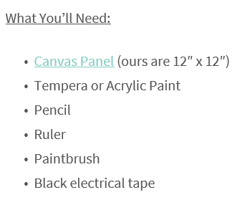Create a piece of art in the style of Mondrian!**

3. Use black tape or draw thick black lines over the pencil marks.

**3**

**1**

**2**

**1**

**2**

NB: If you don’t have some of these resources you can use a black felt-tip or pencil for the outline and coloured pens/pencils.