Friday Writing Activity
The Great Race
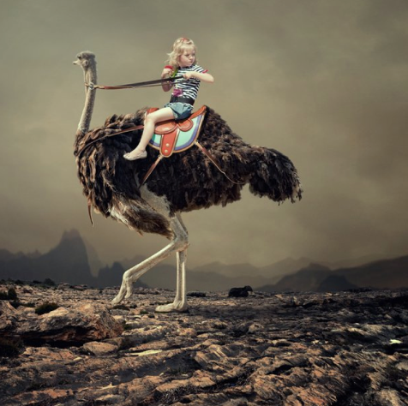

Story starter!
She turned in the saddle and looked behind her. Emma could see the others gaining on her.
Digging in her heels, she whispered some words of encouragement in the ostrich’s ears as it burst into full speed. They were making good time, but there was so far still to go…
Can you continue the story? Who is chasing Emma? Is this a race or is she on another adventure?

