Mime

Mime was part of ancient Greek and Roman entertainment. In the 20th Century famous actors such as Marcel Marceau and Charlie Chaplin used mime on stage and in films.

Mime is a type of acting that does not use words or speech, it is usually silent. Mime is all about how an actor moves and their facial expressions. It often involves very exaggerated expressions. The actors use their actions to send a message or tell a story.

[https://www.youtube.com/watch?v=U7d5rZ944 Vs](https://www.youtube.com/watch?v=U7d5rZ944Vs)

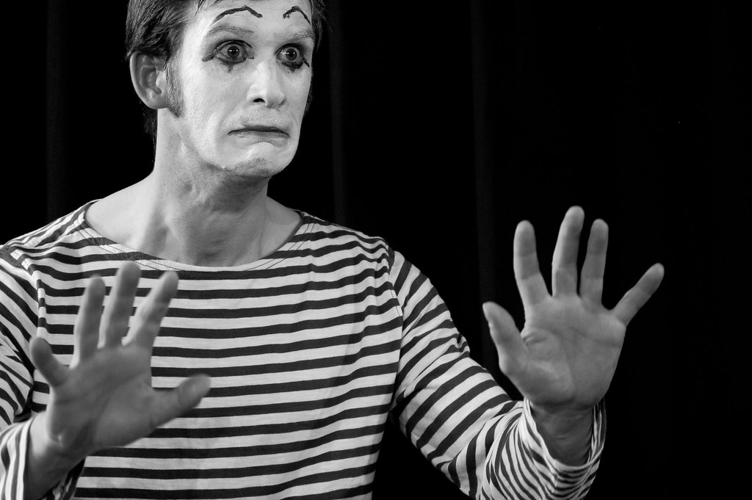

Marcel Marceau

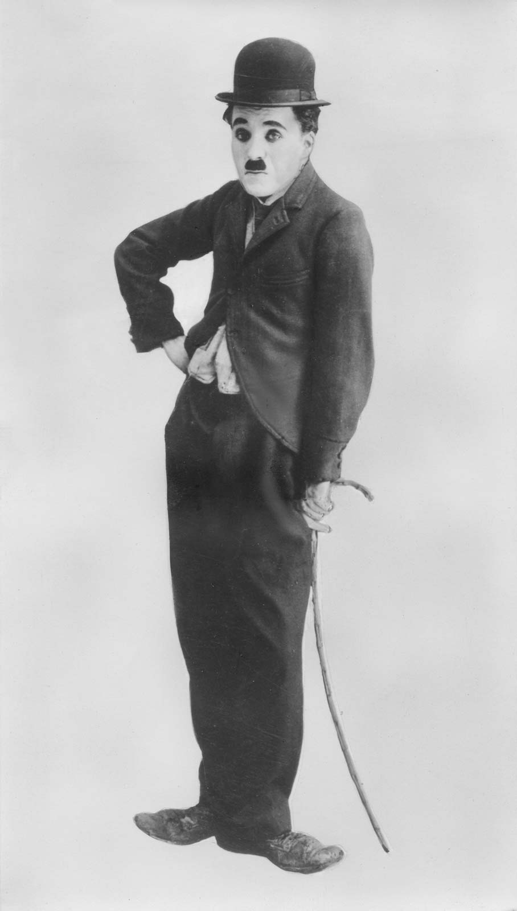

Charlie Chaplin

a weather presenter.

Using mime, pretend to be…

**Mime**Challenge Cards

Think about the way they might move, their body language, their facial expression and what they might be doing.

Using mime, pretend to be…

Using mime, pretend to be…

someone winning   
a race.

an angry car driver.

Think about the way they might move, their body language, their facial expression and what they might be doing.

Think about the way they might move, their body language, their facial expression and what they might be doing.

someone who has hurt   
their knee.

a bored child.

Think about the way they might move, their body language, their facial expression and what they might be doing.

Think about the way they might move, their body language, their facial expression and what they might be doing.

a conductor of   
an orchestra.

a child opening up a really exciting present.

Think about the way they might move, their body language, their facial expression and what they might be doing.

Think about the way they might move, their body language, their facial expression and what they might be doing.

a thief.

someone doing   
the housework.

Think about the way they might move, their body language, their facial expression and what they might be doing.

Think about the way they might move, their body language, their facial expression and what they might be doing.

someone trying to get   
out of bed.

a postman.

Think about the way they might move, their body language, their facial expression and what they might be doing.

Think about the way they might move, their body language, their facial expression and what they might be doing.

Think about the way they might move, their body language, their facial expression and what they might be doing.

Think about the way they might move, their body language, their facial expression and what they might be doing.

Think about the way they might move, their body language, their facial expression and what they might be doing.

Think about the way they might move, their body language, their facial expression and what they might be doing.

someone taking a very strong dog for a walk.

a dentist examining someone’s teeth.

a chatty hairdresser.

someone who has   
just scored a goal in a football game.

Think about the way they might move, their body language, their facial expression and what they might be doing.

Think about the way they might move, their body language, their facial expression and what they might be doing.

someone trying to get the   
attention of someone upstairs   
from the garden by shouting   
and waving.

Think about the way they might move, their body language, their facial expression and what they might be doing.

Think about the way they might move, their body language, their facial expression and what they might be doing.

a piano player who is practising and keeps making a mistake but eventually gets it right.

a teacher.

a film director.

Think about the way they might move, their body language, their facial expression and what they might be doing.

Think about the way they might move, their body language, their facial expression and what they might be doing.

Think about the way they might move, their body language, their facial expression and what they might be doing.

Think about the way they might move, their body language, their facial expression and what they might be doing.

someone cheering on a runner who is winning but then loses.

someone having an argument   
with another person and then storming off.

someone running for a bus which leaves before they get there.

someone walking along the street and it starts to rain.