What to do today
IMPORTANT Parent or Carer – Read this page with your child and check that you are happy with what they have to do and any weblinks or use of internet.

1. Write about a character
- Look at Ananse. How could you describe this character? What is special about him? What sort of things does he do? What words would fit his personality?
- Write your ideas carefully around the picture of Ananse.

2. Plan a story
- Look at Ananse Illustration. Imagine what might be happening here.
- Answer the Story Prompt Questions using your imagination.
- Now plan out a story based on your ideas. Use words and pictures on Story Planner to show how you will tell your story.

3. Now for some writing
- Write your story about Ananse.
- Try to include some adverbials in your writing. The Adverbial Bank may help you.

Try this Fun-Time Extra

- Read the story of Ananse, the Even-Handed judge or find someone to read it to you. This is the story that originally goes with the illustration. How does it compare to yours? Is anything the same? What is different?

Ananse

Ananse Illustration

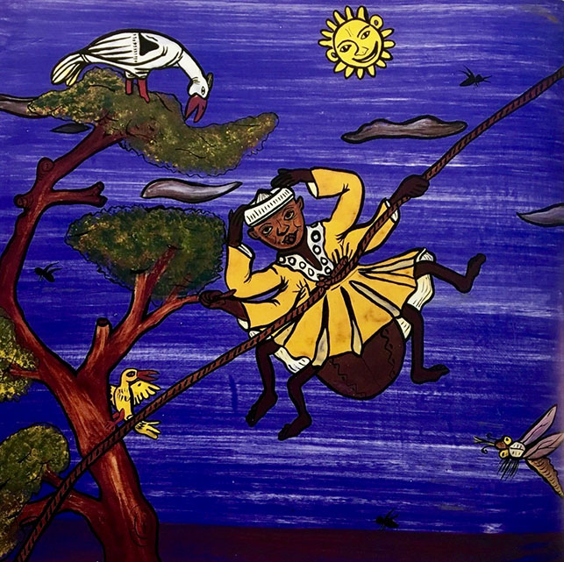

From The Pot of Wisdom by Adwoa Badoe and Baba Wague Diakite

Story Prompt Questions

Why do you think that Ananse is up in the air?

What might he be saying?

What might the bird be thinking?

What do you imagine happened to Ananse just before this picture?

What might happen to him next?
Story Planner
1 | 2 | 3
4 | 5 | 6

Adverbial Bank

Adverbials often start with prepositions or conjunctions

Prepositions |  |  | Conjunctions
When? | Where? | How? | Where? | When? | Why?
before  after  while  in  on  at  during | above  below  inside  outside  to  on  from  under | in  with  as  like | where  wherever | after  before  when  since  until  as  while | because  as  so  since

Ananse Story

Write your story about Ananse here. Try to include adverbials.

Ananse the Even-handed Judge

Ananse’s fame had spread far as a result of his past deeds, and many people now recognized him as a man of much wisdom. As a result, the great king of the forest lands appointed him to be the judge of two villages. It was a job that Ananse took seriously. Day after day he held court in one of the villages and judged wisely for all the people. He became well known for his even-handed judgments.

One Thursday, he received messengers from one of the nearby villages, who invited him to attend a marriage ceremony as a guest of high honour on Saturday. Ananse was pleased to accept. The messengers had barely left when another group of messengers from the chief of the other village requested the presence of Ananse at the funeral of the chief's aunt on the same day.

"This poses a slight problem," said Ananse. "You see, I have already given my word that I would attend a marriage ceremony at the other village."

"Do you mean you have declined to attend the funeral of the chief's aunt, in preference to a marriage ceremony?" asked the messenger.

"Now that poses a real problem with our chief whom you have slighted!"

"I beg your pardon," said Ananse. "I shall be there. Tell the chief it will be an honour to mourn with him." The messengers left at once.

Now Ananse pondered what to do. As a great judge, his word was his bond, and he knew no way to excuse himself from one or the other engagement. He had to find a way to please everyone.

Eventually a plan came to him. He would send one of his sons to each village ahead of time. Each son would take along a very strong rope spun of spider silk, which Ananse had tied around his waist. (Remember that Ananse was still a spider and good at spinning webs.) When it came time for a party to start, all his son had to do was tug his rope hard. Ananse would go to the place toward which he was tugged first. Then at the first opportunity he would leave for the next village.

On the Saturday of the festivities, Ananse bathed and dressed himself in his best clothes—dark enough for mourning and bright enough for rejoicing. He secured the silken ropes firmly around his waist and sent his sons on their way. Then he sat down to wait, quite pleased with himself.

Eventually he felt a tug toward his left side. "The marriage ceremony has started," he thought. "I had better be on my way." No sooner had he started off when the rope on his right side was pulled hard. And then both ropes were pulling so hard that Ananse could hardly breathe. The wise judge had forgotten to tell his sons to stop pulling after the initial tug, and now the brothers were involved in a tug of Ananse, which nearly tore him clean in two.

By the time passers-by freed Ananse from his ropes, he could hardly walk. He was quite unable to go to either of the ceremonies, and his great reputation for wisdom was ruined as the people laughed at his folly. Fearing that no one would ever listen to his judgments again, he fled to the corner of his room to hide his face.

