What to do today
IMPORTANT Parent or Carer – Read this page with your child and check that you are happy with what they have to do and any weblinks or use of internet.

1. Read the end of the story.
- Read Ananse, the forgetful guest – Part 2. This is the end of the story we began on Day 1. How does this ending compare with the ending that you predicted?

2. Remind yourself about adverbials
- Use the PowerPoint on adverbials to listen to the teaching. If this is not possible, remind yourself using the Revision Card.
- Complete Ananse Adverbials. Underline the main verbs and highlight the adverbials.

3. Now for some writing
- Re-write each of the sentences from Ananse Adverbials with a new adverbial. You could challenge yourself to write two new versions for each sentence.

Well done! Now show a grown-up the sentences that you have written. Explain to them the adverbials that you have used.

Try these Fun-Time Extras

- Can you write a playscript for this part of the story? You could act it out with other people in your house, or with toys.
- Can you make an illustration of Ananse in his farm clothes when everyone else was dressed for celebration?

Ananse, the forgetful guest – Part 2

This is the end of the story about Ananse - the half-spider/half-man character.
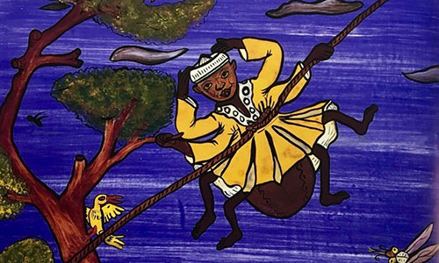

The last day of Ananse's visit fell on the harvest celebrations. A great feast was anticipated. By now Ananse wished strongly that he could be allowed just a small bite of cassava, which the people of Po-Ano cooked in so many delightful ways. There were spicy cassava fries, cassava and vegetable stir-fry, not to mention the soups and stews with which cassava was served.

That night, he hatched a plan. The next day dawned bright. Everywhere, people bustled about preparing food and preparing themselves for the feast in the public square where the king would be in attendance. Early that afternoon the people of Po-Ano gathered and the king made his entrance. But Ananse was nowhere to be found.

Then in the lull before the dancing started, a very odd figure in the rough clothes of a farm labourer appeared.

"Ananse!" the king thundered. "What is the meaning of this...this insult! Why aren’t you wearing proper clothes?"

"I beg your pardon, sir, but I thought we were going harvesting today," said Ananse.

"No!" shouted the crowd. "Today is the harvest celebration!"

"Oh, no," said Ananse, hanging his head in apparent shame. "You must think I'm crazy but really I'm not. It is just this awful forgetfulness that comes over me occasionally. It is the same forgetfulness that made me say cassava was forbidden to me when actually it is one of my favourite vegetables!"

The king was pleased to forgive him and pleased that he did eat cassava. The people of Po-Ano were pleased to share their feast with him. Many secretly thought that Ananse was kind of strange, but since his visit people sometimes plead his kind of forgetfulness whenever they are caught in a sticky situation.

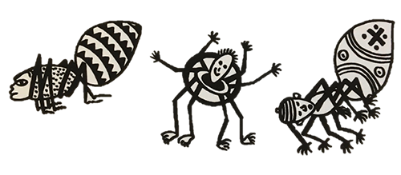
Revision Card – Adverbials

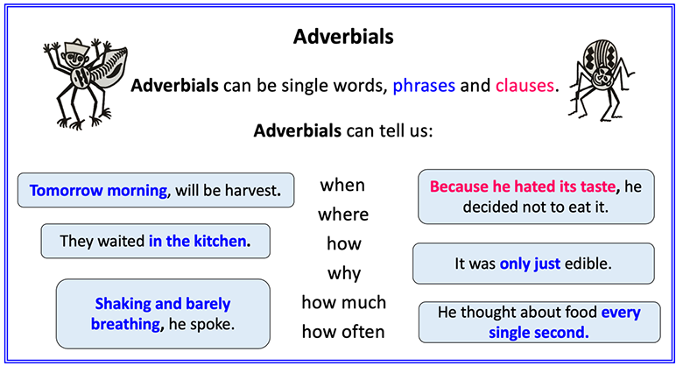
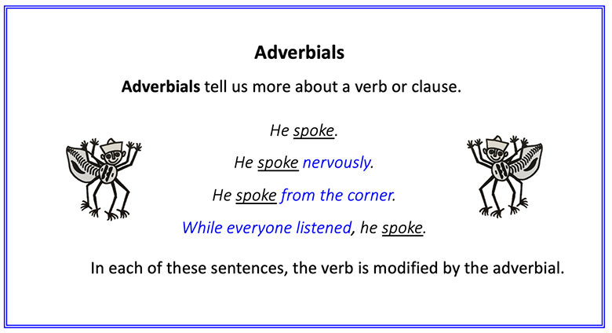
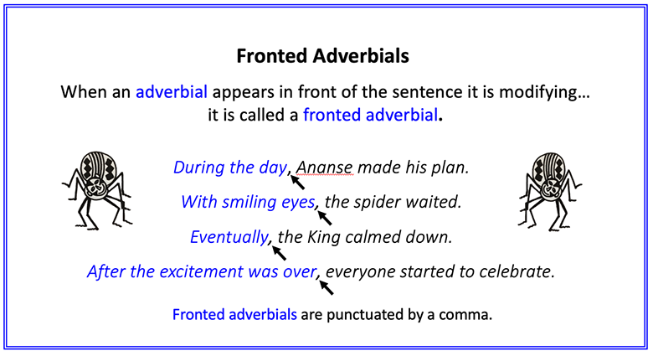

Ananse Adverbials

Underline the main verb and highlight the adverbial. Write whether it is answering WHEN, WHERE or HOW.

1. Ananse had journeyed through the forest lands.

2. After several days of tracking through the forest, his journey was completed.

3. On the nights spent in the forest, he had dreamed of food.

4. At last, he was in the great town of Po-Ano.

5. In the palace, Ananse could smell delicious food.

6. Ananse dressed excitedly.

7. With a flourish, the king’s wife lifted the lid.

8. Ananse collapsed in shock.

9. In the forest lands, this was called Face-the-Wall.

10. Thinking quickly, Ananse made a plan.
Ananse Adverbials - ANSWERS

1. Ananse had journeyed through the forest lands. (WHERE)
2. After several days of tracking through the forest, his journey was completed. (WHEN)
3. On the nights spent in the forest, he had dreamed of food. (WHEN)
4. At last, he was in the great town of Po-Ano. (WHEN)
5. In the palace, Ananse could smell delicious food. (WHERE)
6. Ananse dressed excitedly. (HOW)
7. With a flourish, the king’s wife lifted the lid. (HOW)
8. Ananse collapsed in shock. (HOW)
9. In the forest lands, this was called Face-the-Wall. (WHERE)
10. Thinking quickly, Ananse made a plan. (HOW)
New Sentences
Re-write the Ananse Adverbial sentences with new adverbials. The Adverbials Bank could help you with ideas.

Adverbial Bank

Adverbials often start with prepositions or conjunctions

Prepositions |  |  | Conjunctions
When? | Where? | How? | Where? | When? | Why?
before  after  while  in  on  at  during | above  below  inside  outside  to  on  from  under | in  with  as  like | where  wherever | after  before  when  since  until  as  while | because  as  so  since

