¡Hola!

Lesson 6:
- Write the date in Spanish in your book:
Hoy es___________, _____dev______________del 2020.

Are you a good detective? Let´s see...
- In following sentences about me there are some pictures instead of words. Can you tell me which words are?
a) Soy de
b) Mi color favorito es el
c) Me gustan y
d) No me gusta el color

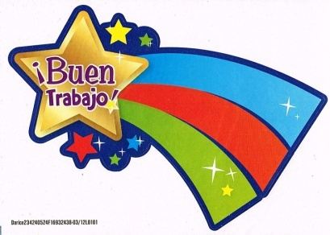
- I know we learnt the colours the first term! Try to remember; if not use the app wordreference.com ( bilingual dictionary)

IF YOU WANT TO SEND ME YOUR WORK or ANY QUESTIONS ccs@tda.education

