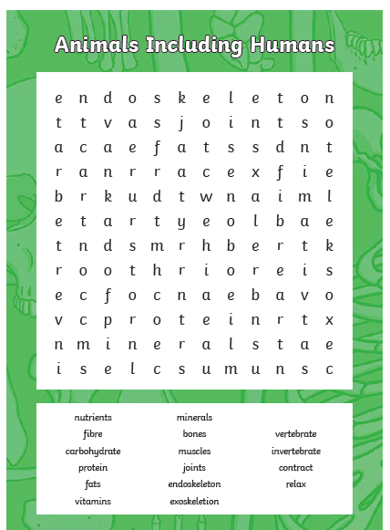
Can you use any of these words in a sentence?

