Send me your work or any questions at ccs@tda.education
¡Hola chicos y chicas!
Hoy es___________, _____de______________del 2020

Now complete the dialogues with sentences or words from last week learning ( try not to look). It needs to make sense! So make sure you know what do they mean

1.
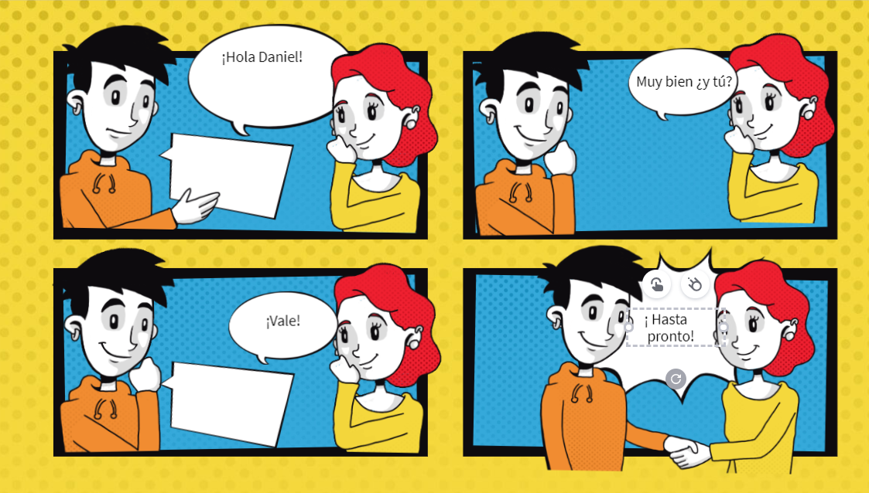

2.

