Pyramids of biomass: FIT Task
We can measure the amount of biomass at different trophic levels in a food chain. The total biomass of each trophic level is often represented as a modified bar chart called a pyramid of biomass. In a food chain from a healthy ecosystem the biomass at each trophic level must reduce. An example of a food chain is:
clover → snail → thrush → sparrow hawks
So in an ecosystem the clover has more biomass than all the snails, which have more biomass than all the thrushes and so on. We say that pyramids of biomass are always perfectly shaped. If this is not the case, then the ecosystem is likely to be unhealthy and in danger.
Pyramids of biomass must be drawn with the:
- bars equally spaced around the midpoint
- bars touching
- bar for the producer at the bottom
- length of each bar is proportional to the amount of biomass available at each trophic level

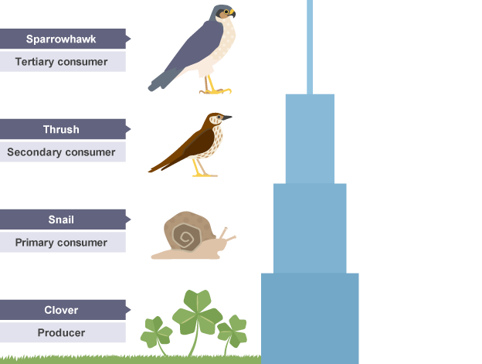

FIT Task
Q1) Revisit the Pyramids of Biomass exam question. Draw the Pyramid of Biomass axis from the question sheet and complete the questions.

Q2) Complete the pyramids of biomass questions.

Self-assess using purple pen from the mark schemes.
Email if any questions/ further support required CSE@tda.education

Q1. Figure 1 shows:
• a food chain for organisms in a river
• the biomass of the organisms at each trophic level.
Figure 1
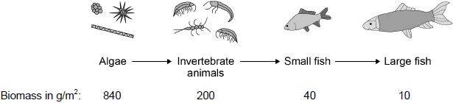
(a) Draw a pyramid of biomass for the food chain in Figure 1 on Figure 2. You should:
• use a suitable scale
• label the x-axis
• label each trophic level.
Figure 2
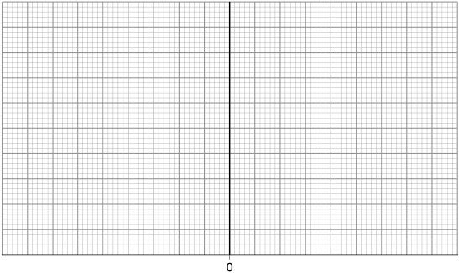
(4)
(b) Calculate the percentage of the biomass lost between the algae and the large fish.
Give your answer to 2 significant figures.
___________________________________________________________________
Percentage loss = __________________
(3)
(c) Give one way that biomass is lost between trophic levels.
__________________________________________________________(1) (Total 8 marks)

Q2

More about pyramids of biomass
This diagram shows a pyramid of biomass for the organisms in a pond.
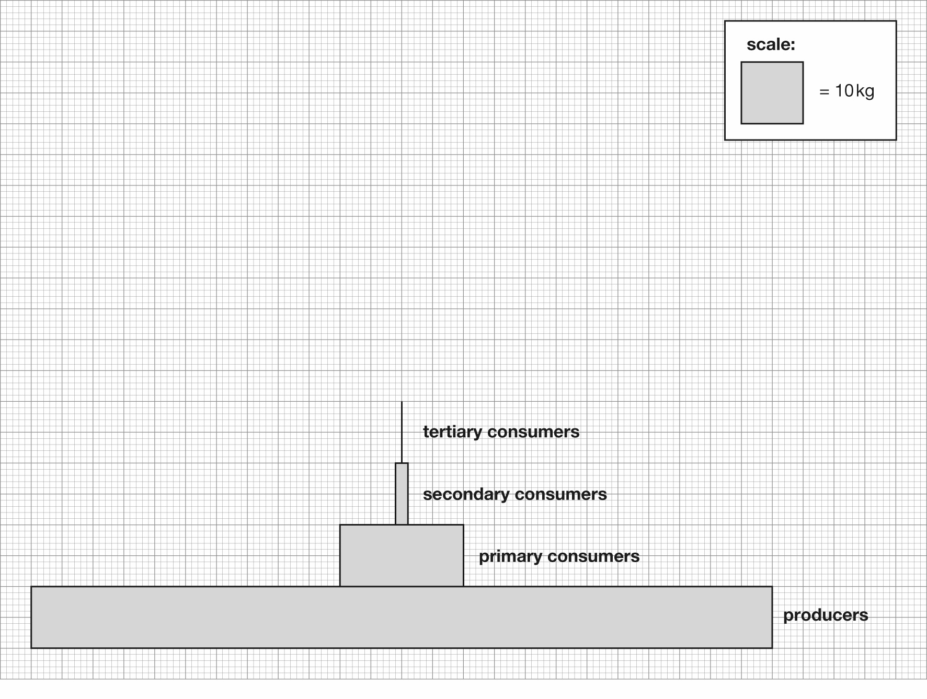

Questions
1 Each 1 cm square represents 10 kg of biomass. What is the biomass of the producers in the pond?
_____________________ kg
2 What is the biomass of the primary consumers in the pond?
_____________________ kg
3 Suggest the names of some organisms in the pond that could be:
Producers ____________________________________________
Primary consumers ____________________________________________
Secondary consumers ____________________________________________
Tertiary consumers ____________________________________________
4 Which of the organisms you have named in question 3 are herbivores?
__________________________________________________________________________
__________________________________________________________________________

Drawing a pyramid of biomass
5
This table shows the mass of the populations of different kinds of organisms in a large pond.

Organisms | Total mass / kg
Producers | 240
Primary consumers | 20
Secondary consumers | 2
Tertiary consumers | 0.2

On the grid below, use the data to construct a pyramid of biomass.

Mark Schemes
Q1.
(a) x-axis: scale + labelled, including units
scale ≥ ½ width of graph paper label: biomass in g/m²
1
bar widths correct
± ½-square each side
allow 1 mark if 3 correct
2
all 4 bars correctly labelled
large fish + small fish + invertebrate (animals) + algae
or
(trophic level) 4 + 3 + 2 + 1
or
tertiary consumer + secondary consumer + primary consumer + producer
ignore bar heights
1
(b) 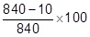
allow equivalent calculation
1
98.809523... / 98.810 / 98.81 / 98.8
1
99
allow answer given to two significant figures from an incorrect calculation in step 2
1
an answer of 99 scores 3 marks
(c) inedible parts / example
allow eaten by other animals or not all organisms eaten
or
egested / faeces
allow not digested
allow excretion / urine
ignore waste
or
respiration / as CO₂
ignore energy losses
ignore movement

Q2
1 120 kg.
2 20 kg.
3 Possibilities include:
- producers; any water plants
- primary consumers; tadpoles, herbivorous fish, pond snails
- secondary consumers and tertiary consumers; frogs, water boatmen, dragonfly larvae, water beetles, newts
- The primary consumers are herbivores.

5

https://www.youtube.com/watch?v=sgh1OWm0oTQ
(Free Science Lessons)
https://www.bbc.co.uk/bitesize/guides/zs7gw6f/revision/2

