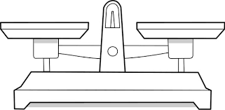
Add statements onto the scales that will help you structure your essay answer ….
Assess the potential for water conflict in areas where demand exceeds supply (8)
WON’T
WILL

