HERE & NOW
Project Year 7 & 8
There are 2 themes to choose from:
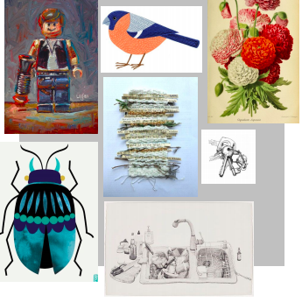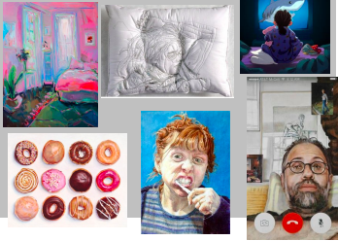
1.Finding the Joy in the Small Things

When we have time on our hands, and time feels like it slows down, we notice things that we possibly wouldn’t notice otherwise in our usually busy lives. Things and objects around us look different, we pay more attention to close observation. We begin to find the joy in the small things – the ordinary and the mundane.
What have you noticed or began to appreciate at home?
2. Habits and Routines

What new habits have you got? What routines have you created for yourself, or even lack of routine? What activities have you been doing every day?
What does life look like for you and your family? Have you been finding yourself in odd/funny situations out of boredom, how you do stay entertained?
What objects, communication, food, activity, tv shows have been a big part of your everyday?
or
Week commencing: | Finding the Joy in the Small Things | Habits and Routines
15/06/20 | Take a photograph of an everyday item that you have grown to really appreciate. This could be a person, object or thing. Draw it if you can’t photograph. | Take an aerial photograph (taken from above) of your ‘Corona survival kit’ – what is in your kit? E.g. phone, food, games console etc. Draw it if you can’t take a photo.
22/06/20 | Create a research page on Lee John Phillips, explain his project he created called ‘Shed’ – add photos and your opinion, | Create a research page on Ekaterina Popova, her theme is ‘home’ explain her work and the items she paints – add photos.
29/06/20 | Draw a wildlife animal OR an item from nature that you feel you brings you joy e.g. a tree, a bird, a flower. Observe and add detail. | On an envelope you have had through the post, draw your favourite view in your home or your garden. Use pencil, pen or resources you have available.
06/07/20 | Using any materials you have available (pen, pencil, colouring pencils) draw the view from a window. Draw the window frame and the scene through the glass – try to capture the essence of the scene. Use mark-making techniques such as cross-hatching. | Illustrate a recipe OR draw your favourite or most memorable dish/plate of food since lockdown. Use any resources you have available (you could even paint with coffee, beetroot juice or turmeric).
13/07/20 | Using old newspapers, magazines and envelopes, create a collage of an object you would typically find in the kitchen. | Draw somebody in your family doing a mundane but necessary activity e.g. brushing their teeth, combing their hair. Take your time – bring your character to life!
Every week… | Send all work to your class teacher via email | Send all work to your class teacher via email

