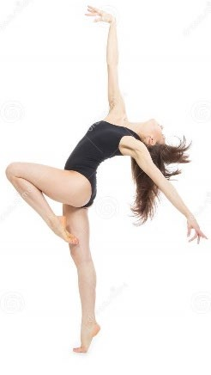
Year 9 Dance - Home Learning Booklet

There are three sections to this booklet so work at your own pace and complete as much as you can over the next 4 weeks.

Section One – Performance Skills
Section Two – Safe Practice
Section Three – Choreography

Task One: Read through Section One – Performance Skills. There are 15 questions for you to answer at the end of that section to check your knowledge and understanding. Use full sentences where appropriate.
Task Two: Read through Section Two – Safe Practice. There are 10 questions at the end of the section. This is multiple choice, you need to identify the one answer that is incorrect.
Task Three: Read through Section Three - Choreography. Using the information provided create either a word search using key words, a quiz or a poster using the key information provided.

Section One - Performance Skills

There are four types of performance skills:
Physical Skills | • | Prevent injury
 | • | Make dance look aesthetically pleasing
 | • | Allows more challenging movements – more complex lifts, higher jumps…
Expressive Skills | • | Engage the audience
 | • | Communicate emotion/character/theme
 | • | Communicate choreographic intent
Technical Skills | • | Communicate the choreographic intent
 | • | Provide variation and contrast
 | • | Engage and maintain interest of audience
Mental Skills | • | For accurate and successful demonstration of other performance skills
 | • | For safety (concentration)

- Physical Skills
Physical Skill | Definition | How do we improve this skill (over time?)
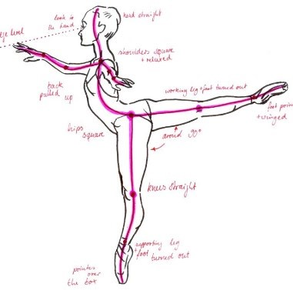  Alignment | The correct placement of limbs – usually in a line | Pliés in parallel and first, dropping shoulders, checking linearity in mirror. Strengthen joints (ankles in relevé)
Balance  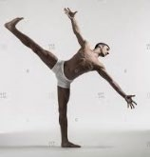 | Ability to hold a position with stillness/control | Improve muscle strength – planks/sit ups/press ups etc and increase amount. Core strength and good focus

Control  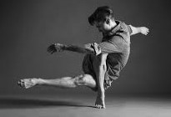 | Ability to change direction/stop or start movement or hold a shape | Improve core strength through sit ups and increase amount each time. Video performance to identify weaker areas
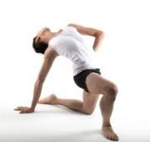  Coordination | Ability to move two or more body parts at the same time | Breaking down movement  phrases into different parts of the body. Layer phrases once confident with each
Extension  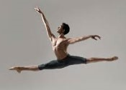 | Fully lengthening limbs/muscles | Improve strength and flexibility in limbs (name exercises) – video performance to identify weaker areas
Flexibility  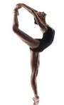 | The range of motion around a joint | Stretching when warm – seated straddle, touching toes (pike), deep lunges. Increase the depth of stretch over time
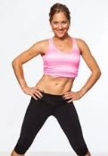  Isolation | Moving a body part independently e.g chest isolation (picture) | Improve strength and clarity in specific limbs/area of the body
Mobility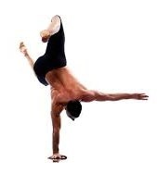 | The ability to move  between actions with fluidity | Improve core strength through sit ups and increase amount over time. Video performance to identify weaker areas
Posture  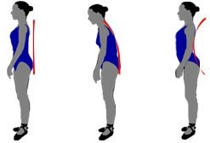 | The body’s position | Improve core strength through sit ups, planks and increase the amount each time. Lift up through top of the head
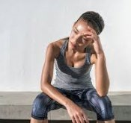  Stamina | The ability to exercise the body for long period of time – the body’s endurance | Improve cardiovascular fitness – running, jogging, circuit training. Increase duration each time
Strength  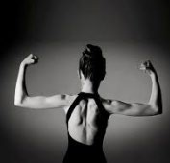 | Muscular power | Sit ups, press ups, plank, squats. Increase the amount/length of time they are performed

- Expressive Skills
Expressive Skill | Definition | Notes
Facial Expressions  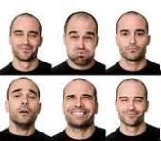 | Using the face to communicate character/ emotion and engage the audience | Facial expressions are choreographed and will help you increase your projection
Focus  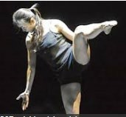 | The dancer’s eye line | Makes movements look  bigger (following circle of arm) directs audience’s attention to certain areas of stage/body parts, shows character (confident character would look up and out)
Musicality  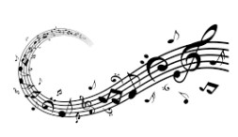 | Showing sensitivity to the aural setting (accents/quality etc) | Four music/movement relationships:  - Music visualisation  - Direct correlation  - Mutual co-existence  - Juxtaposition
Phrasing  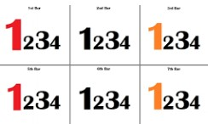 | The distribution of energy within a phrase of movement | Also called ‘emphasis’ i.e. adding emphasis onto particular moments
Projection  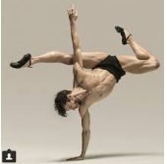 | Using energy to engage the audience | Confidence will help develop your projection. Think about light radiating out from your body and limbs to help you increase the energy
Spatial Awareness  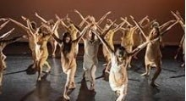 | Being conscious of the surrounding space (stage space, other dancers and audience) | In terms of formations, proxemics, stage directions, pathways

- Technical Skills

Action  Content | 6 basic actions: travel, turn, gesture, stillness, transfer of weight, elevation | 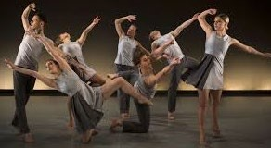  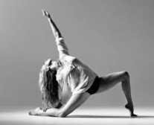
Dynamic  Content | Time, weight and flow: rapid or slow, sudden or sustained, fluid or staccato, gentle or powerful, direct or indirect
Spatial  Content | Levels, directions, spatial pathways, size of movement, proximity to audience, patterns
Relationship  Content | In a duet/group: Lead and follow, mirroring, action reaction, accumulation, complementary and contrast, counterpoint, contact, formations
Timing | Using the same counts to the aural setting or other dancers
Rhythmic  Content | Patterns of movements that can be repeated

- Mental Skills

Movement  Memory  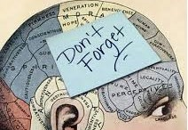 | The ability to  remember phrases/whole choreography (also  called muscle memory) | During the process and preparation before a performance we should practise:  - systematic repetition  - mental rehearsal  - rehearsal discipline  - planning of rehearsal  - response to feedback  - capacity to improve
Commitment  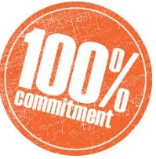 | Dedication to the rehearsal process  and final performance
Concentration  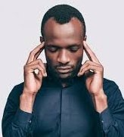 | Focussing all of your attention onto the performance
Confidence  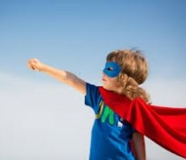 | The feeling of self- assurance and belief in the process and performance

Task One: Now you have read the information in section one, answer the following 15 questions. Use full sentences where necessary.

Section One - Physical Skills Questions
- How many types of performance skills are there? Circle the correct answer.
3, 4 or 5?
- Name each performance skill.
- Give the definition of alignment.
- Give three examples of how to improve balance.
- Extension is the fully lengthening of muscles True or false? Circle the correct answer.
- Give the definition of mobility.
- How can you improve stamina?
- What is facial expression?
- Musicality is showing sensitivity to the aural setting. True or false?
- Fill in the blank. ______________ will help develop your projection.
- Under action content name 6 basic actions:
- What is timing?
- Rhythmic Content are patterns of movements that can’t be repeated. True or false?
- What is movement memory?
- Fill in the blanks. Confidence is the feeling of ____________ and ____________ in the process and performance.

Section Two - Safe Practice

Read through the information below.

Safe Practice Information

‘Why it is important for a dancer to warm up before a dance class?’
- Reduce the risk of injury
- Increase heart rate – oxygen supply to muscles
- Improve muscle elasticity
- Lubricate the joints
- Mentally prepare and focus
- Speed up nerve impulses from brain to muscles

Warm Up exercises
- Pulse raisers – jogging, star jumps, jumping
- Alignment exercises – rolling down the spine, tendus, pliés
- Joint mobility – circling ankles, rising on toes, wrist circles, swings
- Gentle stretches – lunges, touching toes from standing
‘Why it is important for a dancer to cool down after a dance class?’
- Return heart rate to normal
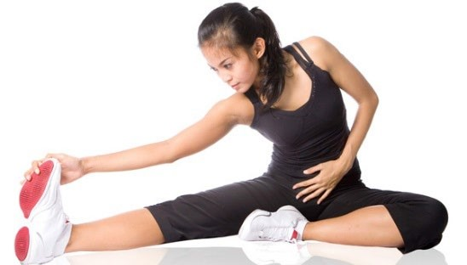
- Prevent pooling of blood
- Reduce muscle pain and joint stiffness

Cool down exercises
- Stretching – lunges, cobra stretch, yoga stretches
- Deep breathing whilst circling arms above head
Other safe practice considerations:
- Staying hydrated and drinking enough water
- Eating a balanced diet – plenty of carbohydrates for energy
- Getting enough sleep – alert for physical activity

Health and Nutrition
Carbohydrates: slow releasing energy (bread, pasta, potatoes – the brown foods!)
Protein: for growth and repair of cells, in particular muscles (meat, fish, dairy, nuts)
Fats: quick releasing energy and insulation (need a small amount for energy only) (chocolate, butter, oil, friend foods)
Vitamins and minerals: For healthy skin, joints, eyes, strong bones (Vitamin C – citrus fruits, Vitamin D – dairy, iron – leafy greens, calcium – dairy)
Fibre: important for digestive system (cereals, bread, fruit and vegetables)
Water: increase energy and alertness, staying hydrated, replenishing lost sweat Studio Safety
- Correct temperature – not too cold (bad for your muscles)
- No obstacles in the space/ Flat floor (trip hazards)
- No spillages (slip hazards)
- Enough space between dancers (collision hazard)
- Correct dance uniform – no shoes or socks, flexible clothing (non-restrictive and ensures no slipping)
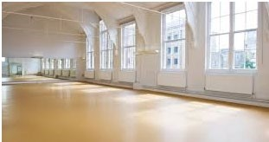

Safe practice in movements
- Make sure your alignment is correct– when bending your knees, the knees should go over the toes –reduces stress on the joints
- When lunging, make sure your knee does not go further than your toes – no hyperextension to stress the joints
- When lifting others, make sure you are in the correct position (stable base) and bend your knees to protect your spine and back muscles
- Bend your knees when landing jumps to transfer weight safely into the floor and reduce shock in the joints
- Articulate the feet properly when landing jumps – use toes to ball to heel to land safely and reduce shock travelling up the leg
EURGH! ALIGNMENT!!
- Not knocking knees on the floor during floor work/rolls
- When transferring weight into the floor, use hands and make contact with muscular parts of the body
- Correct posture throughout to reduce stress on the spine
To improve the rehearsal process:
- Video recording and self-assessment
- Peer/teacher feedback
- Working with/without the accompaniment

Section Two - Safe Practice Questions
With each question there is one wrong answer out of the three suggested. Circle or write down the wrong answer.

- Why it is important for a dancer to warm up before a dance class?’
- Reduce the risk of injury
- Lubricate the joints
- Return heart rate to normal.

- Why it is important for a dancer to cool down after a dance class?’
- Prevent pooling of blood.
- Reduce muscle pain and joint stiffness.
- Speed up nerve impulses from the brain to muscles.

- Safe practice considerations are;
- Eating lots of chocolate.
- Staying hydrated and drinking enough water
- Eating a balanced diet – plenty of carbohydrates for energy

- Foods considered Carbohydrates are;
- Pasta
- Cheese
- Bread

- Foods considered Proteins are;
- Meat
- Potatoes
- Nuts

- Foods considered Fats are;
- Butter
- Oil
- Rice

- Vitamins and minerals are found in;
- Citrus fruits
- Sugar
- Leafy greens

- Fibre is:
- Butter
- Bread
- Vegetables

- To ensure a safe dance studio you must ensure the following;
- Correct temperature – not too cold (bad for your muscles)
- No spillages (slip hazards)
- Dancers must wear socks.

- Safe practice in movement means that you;
- Make sure your alignment is correct– when bending your knees, the knees should go over the toes –reduces stress on the joints.
- Bend your knees when landing jumps to transfer weight safely into the floor and reduce shock in the joints
- When catching somebody close your eyes and hope for the best.

Section Three - Choreography

Task Three: Read through Section three - choreography. Using the information provided create either a word search using key words, a quiz or a poster using the key information provided.

Key words when describing technical skills in choreography.
ACTIONS: 1) jump/elevate, 2) turn/rotate,  3)travel, 4) balance/stillness, 5) gesture, 6) fall | DYNAMICS: sharp, sustained, fast, gentle, robotic, powerful, light, lively, bouncy, fluid, tense, slow, energetic, heavy, mechanical
SPACE: circular/linear/zig zag pathways, high/medium/low levels/ open/intricate movements, directions, formations, proximity of dancers to each other and audience | RELATIONSHIPS: lead and follow, mirroring, action reaction, accumulation,  complementary and contrast, counterpoint, contact, formations

Highlights: create moments of interest which grab the audience’s attention e.g. a lift, change in action/dynamic/spatial content, elevation.
They should enhance the theme/choreographic intent

Climax: the high point in the dance which usually occurs near the end (before the resolution.) Effective ways to create a climax are through elevation (jumping,) travelling, fast dynamics. It should emphasise the theme of the dance

Relationships
Relationships | Definition
Lead and Follow | Same action at the same time
Mirroring | Creating a symmetrical image with body shape
Accumulation | Dancers join in on a phrase giving a sense of growing/building up
Complement and contrast | Movements are performed that have similar/different dynamics and actions
Action Reaction | When one dancer performs an action which initiates a response from another for example, one dancer push into space, other dancer falls back
Counterpoint | When dancers perform different phrases of movement at the same time
Contact | Performing an action/phrase more than once
Formations | The shape(s) that the dancers perform in

What is a motif?
“A short phrase of dance which communicates the theme and is often repeated and developed”

Choreographic Devices
Why are choreographic devices important?
- Make dance more interesting and engaging
- Enhance the stimulus/theme
- Add variety and contrast within the choreography
Choreographic Device | Definition
Unison | Same action at the same time
Canon | Performing an action one after the other
Contrast | Creating a symmetrical image with body shape
Manipulation of number | Changing the number of dancers performing the movement e.g. ensemble, solo, duet, trio, quartet
Repetition | Performing an action/phrase more than once
Highlights | Moments which stand out to the audience
Climax | The most intense part of the choreography, towards the end
Motif Development | Changing the motif through action, space or dynamics

